**LAB-09**

**Configure the following scenario by applying the LACP method (eth-trunk) in eNSP.**

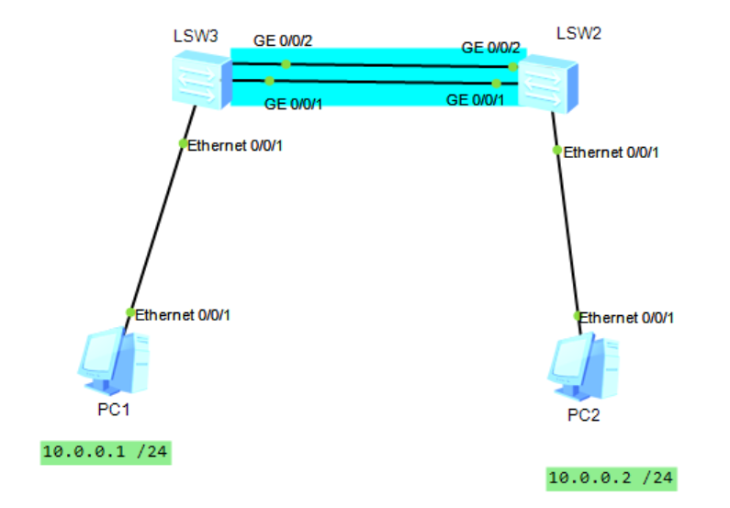**eNSP simulation:**

First, we assigned the IP addresses to both PCs then we apply these commands on both switches to configure LACP.

**Configuration on LSW2:**

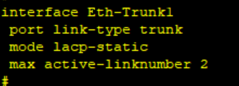

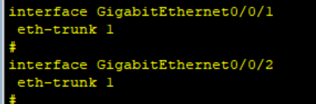

**Configuration on LSW3:**





We can check the status through this command

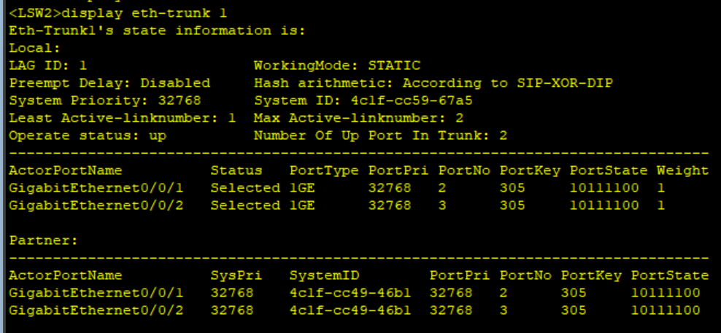**LSW2:**

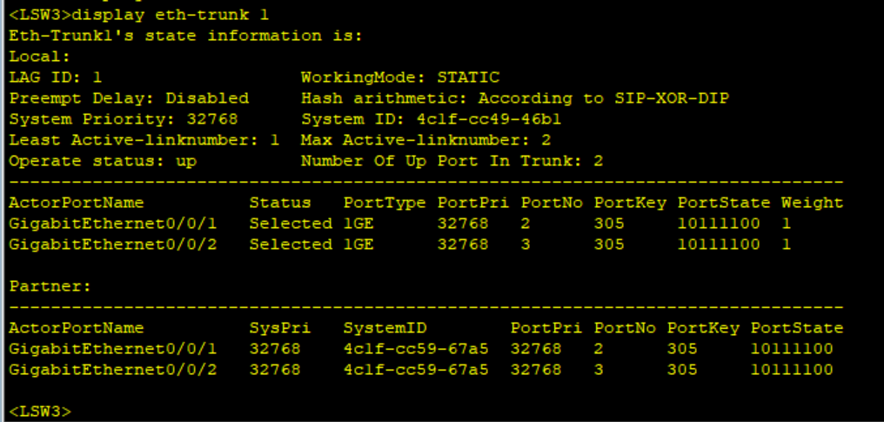**LSW3:**